Xray progress 04-01-2026

Regression Suites
Definition
A Regression Suite is a structured collection of Tests executed to validate that recent code changes have not introduced defects in existing functionality.
Xray Implementation
- Use Test Sets to represent regression suites.
- Suites are organized by scope and risk, not by release.
Recommended Regression Suites
- Smoke Regression
- Critical Regression
- Full Regression
- Module-based Regression
  - Signup
  - Login
  - Payments
  - Profile
Best Practices
- One Test Set per suite
- No test duplication
- Tests can belong to multiple suites
- Naming convention:
Regression – <Suite Type> – <Module>

Reusable Test Packs
Definition
Reusable Test Packs are stable, frequently used test collections that can be reused across multiple releases, environments, and test plans.
Xray Implementation
- Use Test Sets as reusable test packs.
- Link the same Test Set to multiple Test Plans.
Examples of Reusable Test Packs
- Core Authentication Tests
- Signup Validation Tests
- Payment Flow Tests
- API Health Checks
- Role-Based Access Tests
Benefits
- Single source of truth
- Reduced maintenance effort
- Consistent regression coverage
- Faster test planning
Smart Test Selection
Goal
Execute only impacted regression tests instead of full regression, whenever possible.
A. Requirement-Based Selection
- Link Tests ↔ Stories / Bugs
- Select Tests impacted by changed requirements.
Xray Feature Used
- Requirement Coverage
- Traceability Matrix
B. Risk-Based Selection
- Categorize Tests by risk or priority:
  - Critical
  - High
  - Medium
  - Low
- Execute based on release risk.
C. Component / Label-Based Selection
- Tag Tests with components or labels.
- Select Tests using JQL.
Example JQL
project = APP AND issuetype = Test AND labels = signup

D. Defect-Driven Selection
- When a defect is fixed:
  - Execute linked Tests
  - Execute related edge-case Tests
- Prevent regression of past defects.

Regression Execution Flow
Change Identified
↓
Impacted Tests Selected
↓
Test Plan Created
↓
Test Execution Created
↓
Execution & Reporting

Strategy by Release Type
Release Type | Regression Approach
Hotfix | Smoke + Impacted Tests
Minor Release | Impact-Based Regression
Major Release | Full Regression
Patch | Defect-Focused Regression

Key Benefits
- Faster regression cycles
- Optimized test execution
- High test reusability
- Clear traceability and coverage

Key Xray Objects Mapping
Concept | Xray Entity
Regression Suite | Test Set
Reusable Test Pack | Test Set
Regression Cycle | Test Execution
Release Scope | Test Plan

Traceability Strategy (Xray + Jira)
Objective
Ensure end-to-end visibility from business requirements to test results and defects, enabling:
- Complete coverage
- Impact analysis
- Gap identification
- Release readiness decisions

End-to-End Traceability Flow
Requirement (Story / Epic)
↓
Test
↓
Test Execution
↓
Defect
Xray Linkage Model
Entity | Jira Issue Type
Requirement | Story / Task / Epic
Test | Test
Execution | Test Execution
Defect | Bug
Requirement → Test Traceability
Purpose
Ensure every requirement has adequate test coverage.
How it works in Xray
- Tests are linked to requirements using:
  - Tests panel
  - Link existing Test
- One requirement can have:
  - Multiple Tests (positive, negative, edge cases)
Best Practices
- Mandatory: every Story must have at least one linked Test
- Use test naming aligned with requirement
- Cover:
  - Functional
  - Negative
  - Boundary scenarios
Test → Test Execution Traceability
Purpose: Track what was executed, when, and with what result.
How it works
- Tests are added to a Test Execution
- Execution captures:
  - Pass / Fail / Blocked
  - Evidence
  - Environment
  - Executor
Benefits
- Clear execution history
- Environment-wise reporting
- Release-specific status

Execution → Defect Traceability
Purpose
Connect failed tests to actual defects.
How it works
- Raise Bug directly from Test Execution
- Bug is automatically linked to:
  - Failed Test
  - Test Execution
  - Requirement
Benefits
- Root-cause analysis
- Defect impact assessment
- Retest tracking
Coverage Matrix
What is Coverage Matrix?
A visual report showing coverage status between:
- Requirements and Tests
- Requirements and Executions
- Requirements and Defects
Xray Coverage Types
- Requirement Coverage
- Test Coverage
- Execution Coverage
- Defect Coverage
Example View
Requirement | Tests Linked | Executed | Passed | Failed | Defects
Signup Validation | 5 | 5 | 4 | 1 | 1
Login Feature | 4 | 4 | 4 | 0 | 0
Payment Flow | 3 | 1 | 1 | 0 | 0
Gap Identification
A. Requirement Gaps
Symptoms
- Requirement with no linked Tests
Action
- Create missing Tests
- Link Tests before execution
B. Test Gaps
Symptoms
- Tests created but never executed
Action
- Add Tests to Test Execution
- Validate execution scope
C. Execution Gaps
Symptoms
- Tests not executed in required environment or release
Action
- Create environment-specific Test Executions
D. Defect Coverage Gaps
Symptoms
- Failed Tests without linked Bugs
- Bugs without validation Tests
Action
- Enforce defect creation for failures
- Add regression Tests for defects
Traceability Enforcement Rules (Recommended)
- Story cannot be closed without linked Test
- Test Execution cannot be completed with unreviewed failures
- Bug must be linked to at least one Test
- Regression defect must have a permanent Test
Reporting & Visibility
Key Reports in Xray
- Requirement Coverage Report
- Traceability Matrix
- Test Execution Status Report
- Defect Traceability Report

Xray Reports
Execution Report
Purpose
Shows test execution status for a release, cycle, or environment.
What it answers
- How many tests were executed?
- Pass / Fail / Blocked count?
- What is the execution progress?
- Which tests are still pending?
Key Data Included
- Test Execution status
- Individual Test results
- Execution evidence
- Environment & executor details
Usage
- Daily test status reporting
- Go / No-Go decisions
- Sprint review meetings
Coverage Report
Purpose
Shows how well requirements are covered by tests and executions.
Coverage Types
- Requirement → Test coverage
- Requirement → Execution coverage
- Requirement → Defect coverage
What it answers
- Are all requirements tested?
- Which requirements lack test coverage?
- Which requirements failed?
Best Practices
- Review coverage before starting execution
- Use coverage as a release entry criterion
Traceability Report
Purpose
Provides end-to-end traceability across:
Requirement → Test → Test Execution → Defect
What it answers
- Which tests validate a requirement?
- What execution results exist?
- What defects are linked?
- What is the overall quality status?
Usage
- Audits & compliance
- Impact analysis
- Release sign-off

Dashboards in Jira + Xray

Xray Gadgets
Common Xray Gadgets
- Test Execution Status
- Requirement Coverage
- Test Plan Progress
- Overall Test Status
Best Practices
- Use one gadget per purpose
- Filter by:
  - Project
  - Fix Version
  - Test Plan
- Keep dashboards role-specific

Jira Filters & Saved JQL
Purpose
Enable dynamic dashboards and reports.
Common Saved Filters (JQL Examples)
Unexecuted Tests
project = APP AND issuetype = Test AND status != Done
Failed Tests in Current Release
project = APP AND issuetype = Test AND issue in testExecutionTests("EXEC-1") AND status = Failed
Requirements Without Tests (Coverage Gap)
project = APP AND issuetype = Story AND issue not in coveredByTests()
Open Defects from Test Execution
project = APP AND issuetype = Bug AND status != Done AND issue in linkedIssues("EXEC-1")

Dashboard Types
A. QA Execution Dashboard
- Test Execution Status gadget
- Failed Tests filter
- Open Defects filter
B. Release Readiness Dashboard
- Requirement Coverage gadget
- Execution Progress gadget
- Defect Severity chart
C. Management Dashboard
- Overall Pass % trend
- Open defects by priority
- Coverage % by module

Dashboard Sharing & Governance
Sharing Best Practices
- Share dashboards with:
  - QA Team
  - Product Owners
  - Managers
- Set view-only access for stakeholders
- Use saved filters (not ad-hoc JQL)
Governance Rules
- One owner per dashboard
- Periodic cleanup of unused dashboards
- Consistent naming:
  - QA – Sprint 12 Dashboard
  - Release 2.1 – Test Status

Reporting Lifecycle (Recommended)
Test Planning
↓
Coverage Report
↓
Execution Report
↓
Defect Report
↓
Traceability Report

Key Benefits
- Single source of truth
- Real-time quality visibility
- Faster decision-making
- Audit-ready reporting

Xray Custom Fields (Manual Testing)
Xray provides default custom fields and also allows project-specific custom fields to support structured test design.
Core Xray Test Step Fields
These are used in manual, step-based tests.
1. Action
What it is
- Describes the exact step the tester must perform.
Purpose
- Ensures repeatable and consistent execution.
- Eliminates ambiguity.
Example
- Enter valid username and password
- Click on Submit button
2. Data
What it is
- Input values required to execute the step.
Purpose
- Separates test logic from test data.
- Makes tests reusable with different data.
Example
- Username: user01
- Password: P@ssword123

3. Expected Result
What it is
- System behavior expected after performing the action.
Purpose
- Enables clear Pass/Fail decision.
- Supports audit and traceability.
Example
- User should be logged in successfully

4. Actual Result (Execution-time)
What it is
- Actual system behavior observed during execution.
Purpose
- Captures real behavior for analysis.
- Useful for defect reporting.

5. Status
What it is
- Result of test execution.
Values
- Pass
- Fail
- Blocked
- Not Executed
Purpose
- Measures test progress and quality.

Xray Test-Level Fields
These apply at the Test issue level, not per step.

6. Test Type
Values
- Manual
- Automated
- Generic
Purpose
- Distinguish between manual and automation tests.
- Automation coverage reporting.

7. Test Repository Path
What it is
- Folder-like structure to organize Tests.
Purpose
- Logical grouping (Module / Feature / Release)
- Easy navigation and reuse

8. Preconditions
What it is
- Conditions that must be met before execution.
Purpose
- Avoid repetition across tests.
- Reuse common setup steps.
Example
- User must be registered
- Application must be up and running

9. Environment
What it is
- Environment where test is executed.
Examples
- QA
- UAT
- Production
- Staging
Purpose
- Environment-specific execution tracking.

Common Custom Fields (Project-Specific)
These are recommended but configurable.
Field | Purpose | What it Identifies
Priority | Test importance | Critical paths
Risk Level | Business risk | Smart regression
Test Category | Functional / Regression | Coverage analysis
Component | Feature/module | Impact analysis
Labels | Tags | Smart selection
Automation Status | Automated / Not | Automation progress

2. Xray Document Generator (Complete)
What is Document Generator?
Xray Document Generator allows you to export Tests, Executions, Plans, and Reports into formatted documents.
Supported Formats
- PDF
- Word (DOCX)
- HTML
Why Document Generator is Used
- Test case documentation
- Execution evidence
- Audit & compliance reports
- Client delivery documents
- Release sign-off artifacts
Document Generator Templates
A. Test Specification Document
Contains
- Test summary
- Preconditions
- Steps (Action, Data, Expected Result)
Used For
- Test case reviews
- Client approvals
- Audit documentation
B. Test Execution Report
Contains
- Execution status
- Tester name
- Environment
- Evidence
- Actual results
Used For
- Release readiness
- UAT sign-off
- Compliance proof

C. Test Plan Report
Contains
- Scope of testing
- Linked Test Sets
- Execution summary
Used For
- Planning reviews
- Management communication

D. Requirement Traceability Document
Contains
- Requirement → Test → Execution → Defect mapping
Used For
- Compliance
- Coverage proof
- Audit reviews

What You Can Identify from Document Generator
You Can Identify | From Which Doc
Test completeness | Test specification
Execution quality | Execution report
Requirement coverage | Traceability report
Release readiness | Test plan + execution
Audit compliance | Traceability + evidence

3. Xray Reports (All Types)
Test Execution Report
Purpose
Track execution progress and results.
Identifies
- Pass / Fail ratio
- Pending tests
- Failed areas
- Execution completeness

Requirement Coverage Report
Purpose
Show how well requirements are tested.
Identifies
- Untested requirements
- Partially tested features
- Failed requirement coverage

Traceability Report
Purpose
End-to-end visibility.
Requirement → Test → Execution → Defect
Identifies
- Missing links
- Impact of defects
- Quality status per requirement

Test Plan Progress Report
Purpose
Track progress of a release or sprint.
Identifies
- Planned vs executed tests
- Execution gaps
- Release readiness

Defect Traceability Report
Purpose
Analyze defects from testing.
Identifies
- Failed tests without defects
- Defects without validation tests
- Regression risk areas

Overall Test Status Report
Purpose
High-level quality snapshot.
Identifies
- Overall pass %
- Risk level
- Go / No-Go indicators

What Gaps Can Be Identified (Very Important)
Gap Type | How Identified
No tests for requirement | Coverage report
Tests not executed | Execution report
Failed tests without bugs | Defect traceability
Bugs without tests | Traceability report
Missing regression coverage | Test plan report

How Everything Fits Together
Custom Fields → Structured Tests
↓
Test Sets / Test Plans
↓
Test Executions
↓
Defects
↓
Reports & Document Generator

Sample image of test coverage report

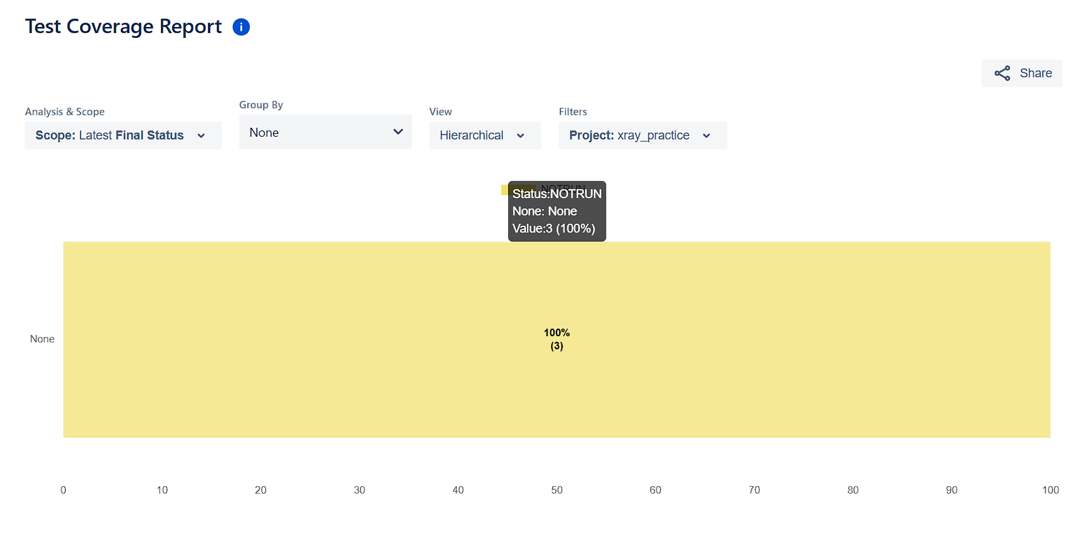
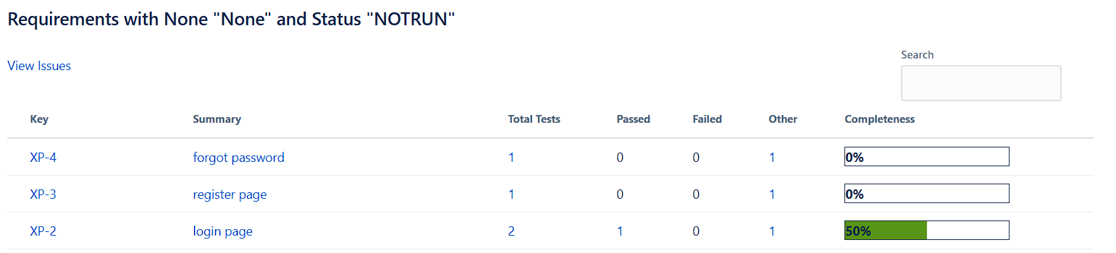

Sample image of Requirement Traceability Report
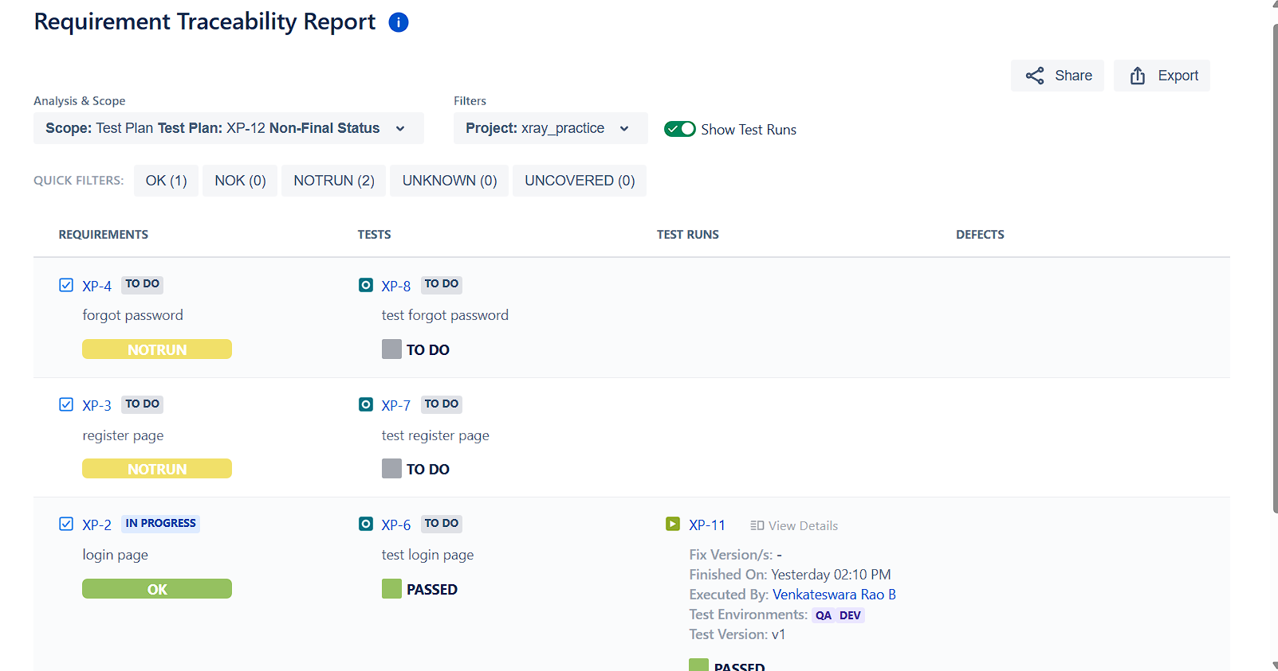
Sample image of doc generator
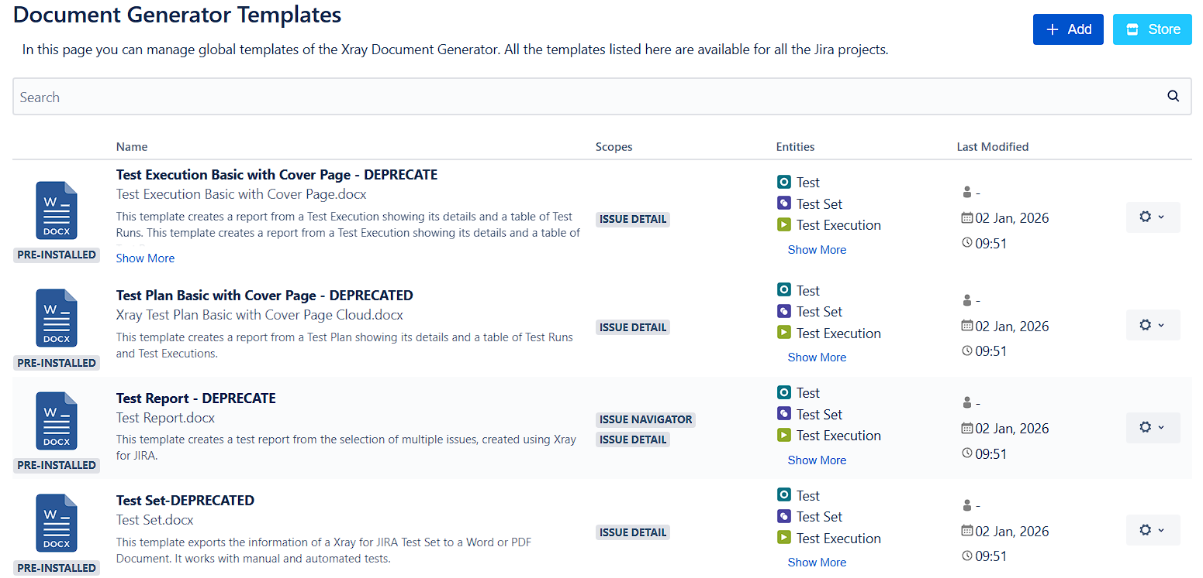

In github repo also attached the sample document report

